**Assignment 2: Write a script that reads numbers from the user until they enter '0'. The script should also print whether each number is odd or even.**

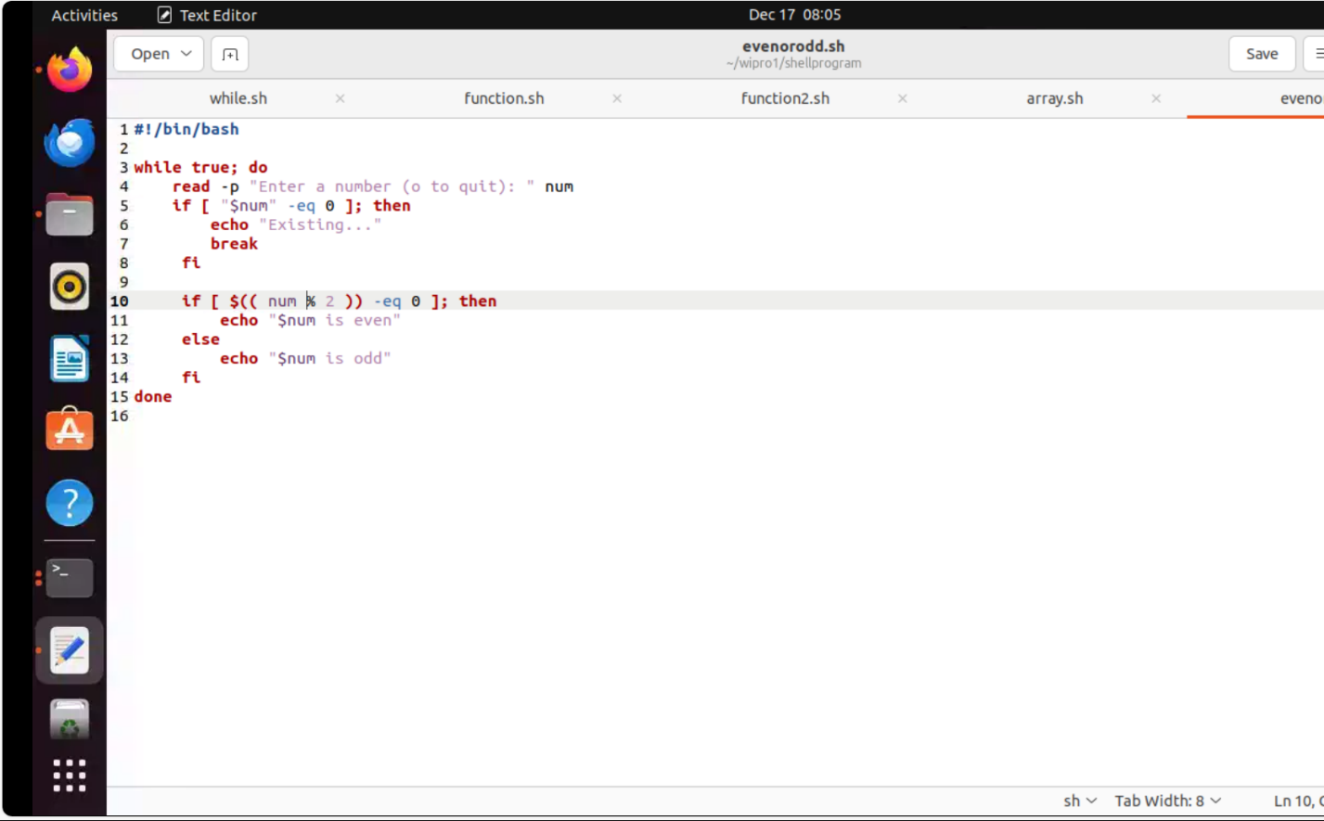

**Output:**

